

Tech-Wiz Documentation On DecorVista Interior Design

DecorVista

|  |  |  |
| --- | --- | --- |
| **FACULTY :** | **SIR MIRZA MOUAVIZ** | |
| **BATCH :** | **2303F.** | |
| **TECH-WIZ :** | **DecorVista Interior Design** | |
| **S. NO.** | **ENROLLMENT NO.** | **STUDENT NAME.** |
| **1.** | * **1525485** | **Unais** |
| **2.** | * **1524134** | **Sufyan** |
| **3.** |  | **Fazil** |
| **4.** | * **1524301** | **Ayaan** |

1.Acknowledgement:

*The first, we would like to express my special thanks of gratitude to my teacher SIR. Zaeem Shaikh who helped a lot in finalizing this project within the limited time frame, valuable counseling and assistance for the accomplishment of this project.*

*Secondly, we would also like to thanks the Tech-Wiz team at Aptech Head Office, who gave as the opportunity to do this interesting and wonderful project about DecorVista Interior Design*

*Thirdly, we also thank the Tech-Wiz team for giving this task to us. Following are the benefits of this Project:*

* *Re-enforcement of skills happens in the experimental learning process.*
* *A mentor, ensuring that we do not get drifted, constantly guide us.*
* *It gives us a lot of confidence to face an interview as we have worked on a project. We can explain virtually everything on the subject we have learnt.*
* And finally, we would like to offer thanks to all my colleagues for their valuable suggestion.

Thank you.

2. Synopsis:

**DecorVista Interior Design Laravel Website Synopsis:**

The DecorVista Interior Design Laravel Website is a comprehensive web application designed to streamline and enhance the operational aspects of a salon or beauty spa. Developed using the Laravel framework, this website offers a user-friendly interface and robust features to meet the specific needs of salon owners, staff, and clients. Key functionalities include:

**Appointment Scheduling:**

Clients can easily book appointments online, selecting specific services, preferred interior designer, and available time slots.

Salon staff can manage and view appointments, ensuring a well-organized schedule for efficient daily operations.

**Staff Management:**

Salon owners can add, remove, or modify staff profiles, assigning roles and responsibilities to streamline the workforce.

Interior designer have personalized accounts to view their schedules, track appointments, and manage client interactions.

**Inventory and Product Management:**

The website allows salon managers to keep track of inventory levels for beauty products and supplies.

Automated alerts notify staff when stock is low, preventing product shortages and ensuring a well-stocked salon.

**Client Profiles and History:**

Each client has a dedicated profile that stores personal information, appointment history, and preferences.

This feature enables personalized service delivery, allowing staff to provide a tailored experience to each client.

**Billing and Invoicing:**

The website includes a billing module to generate invoices for services rendered, facilitating smooth and transparent financial transactions.

Integration with payment gateways ensures secure and hassle-free online transactions.

**Reporting and Analytics:**

Salon owners can access comprehensive reports and analytics to gain insights into business performance, popular services, and client trends.

This data-driven approach empowers salon managers to make informed decisions and optimize their services.

**Responsive Design:**

website is built with a responsive design, ensuring a seamless experience across various devices, including desktops, tablets, and smartphones.

1. PROJECT ANALYSIS:

**1. Project Overview:**

The Web DecorVista Interior Design project aims to create a comprehensive web application to streamline and enhance the operations of a salon or beauty spa.

**2. Objectives:**

Efficient Appointment Scheduling: Provide a user-friendly platform for clients to book appointments online, and for salon staff to manage schedules effectively.

Staff and Inventory Management: Enable salon owners to efficiently manage staff, assign roles, and keep track of product inventory levels to prevent shortages.

Client Relationship Management: Create a system for maintaining client profiles, appointment history, and preferences to offer personalized services.

Billing and Reporting: Implement a billing system for generating invoices and comprehensive reporting tools for analytics and insights into business performance.

**3. Target Users:**

Salon Owners/Managers: Responsible for overall business management, staff supervision, and decision-making.

Salon Staff: Including hairstylists, beauticians, and receptionists who interact with clients and manage daily operations.

Clients: Individuals seeking salon services, including haircuts, spa treatments, and beauty services.

**4. Technology Stack:**

Backend: Laravel PHP Framework for robust and scalable server-side development.

Frontend: HTML, CSS, JavaScript, and a front-end framework (e.g., Bootstrap) for a responsive and user-friendly interface.

Database: MySQL or another relational database for efficient data storage and retrieval.

Payment Integration: Integration with secure payment gateways for online transactions.

**5. Key Features:**

Appointment Management: Efficient scheduling, real-time availability, and automatic notifications.

Staff and Inventory Control: Staff profiles, role assignments, and inventory tracking for optimal salon operations.

Client Profiles: Personalized profiles, appointment history, and preferences for enhanced customer service.

Billing and Invoicing: Automated invoicing for services rendered, including integration with payment gateways.

Reporting and Analytics: Comprehensive reports and analytics for business insights and data-driven decision-making.

**6. Future Enhancements:**

Mobile Application: Develop a mobile app version for on-the-go management and client interactions.

Marketing and Loyalty Programs: Integrate features for marketing campaigns, promotions, and customer loyalty programs.

AI Integration: Explore the possibility of incorporating AI for personalized recommendations and predictive analytics.

**7. Conclusion:**

The Web DecorVista Interior Design project aims to revolutionize salon operations by leveraging modern web technologies, providing a seamless experience for both salon staff and clients. By addressing key challenges and incorporating future enhancements, the system can contribute significantly to the success and growth of salon businesses.

1. PROBLEM STATEMENT

**Introduction**

Elegance Salon is a popular beauty establishment that offers a variety of services including hair styling, manicures, pedicures, and facials. The salon is facing challenges in efficiently managing appointments, handling inventory, and maintaining client records.

DecorVista Interior Design application will enhance operational efficiency, improve customer experience, and streamline business processes for Elegance Salon. By addressing the specific needs of appointment management, client relations, inventory control, and staff scheduling, the salon can optimize its operations and focus on delivering exceptional services to its clientele.

1. PROJECT REQUIREMENTS:

The following are the key features and functionality expected from the application:

**Home Page:**

The home page should be designed to provide an engaging and informative experience for users. It should display information about the Elegance Salon with some images.

**User Authentication and Access Control:**

The system should support different user roles (admin, receptionist, stylist) with distinct access permissions.

Users should log in securely using username/email and password authentication.

**Appointment Management:**

Users can view available time slots for different services.

Ability to book, reschedule, or cancel appointments.

Automated confirmation notifications (email/SMS) for booked appointments.

**Client Management:**

Maintain a centralized client database with details like name, contact information, services availed, and appointment history.

Allow searching, adding, editing, and deleting client profiles.

Record client preferences for specific stylists or services.

**Inventory Management:**

Track inventory levels for salon supplies (e.g., hair products, beauty supplies).

Receive alerts for low inventory and generate automatic purchase orders.

Record supplier information and cost details for inventory items.

**Staff Management:**

Manage staff profiles with details like name, contact information, work schedule, and commission rates.

Enable the assignment of tasks, shifts, and services to stylists.

Calculate and track commissions based on services performed.

**Scheduling and Calendar Integration:**

Provide a calendar view for easy scheduling and managing of appointments and staff shifts.

Ability to sync appointments with external calendars (Google Calendar, iCal) for better organization.

**Reporting and Analytics:**

Generate reports on appointments, sales, inventory levels, and staff performance.

Provide insights into popular services, peak booking hours, and inventory usage trends.

**Payment and Invoicing:**

Record and manage payments made by clients for services rendered.

Generate invoices or receipts for services provided and products sold.

**Notifications and Reminders:**

Automated reminders for upcoming appointments to clients and interior designer.

Notifications for low inventory, pending payments, or other critical updates.

**Admin Panel**:

Develop an admin panel to manage stock & inventory, user accounts, and content updates.

**Contact Us:**

This menu option should display Email id, address, and contact number of the organization who is developing the application.

**Submit Feedback:**

Users can submit their feedback regarding the application using a feedback form.

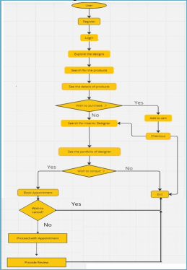



6. SCOPE OF THE WORK:

The scope of the Website DecorVista Interior Design project encompasses the development of a robust and user-friendly web application tailored to meet the specific needs of salon and beauty spa establishments. The primary focus is on creating an efficient appointment scheduling system, allowing clients to book services seamlessly and enabling salon staff to manage their schedules effectively. The system will also incorporate features for staff and inventory management, ensuring optimal workforce utilization and preventing product shortages. Client relationship management functionalities will include the creation of personalized profiles, maintaining appointment histories, and tracking client preferences for a tailored service experience. Additionally, the project involves implementing a secure billing system with online payment integration and comprehensive reporting tools for analytics. The website will be designed to be responsive, ensuring a smooth experience across various devices. The scope recognizes the importance of security measures to protect sensitive client information and emphasizes user-friendly interfaces for both salon staff and clients. The ultimate goal is to enhance the overall efficiency and client satisfaction of salon businesses through modern technological solutions.

7. FLOWCHART/SITEMAP:

7. Source code:

Navbar:

This file is located in the folder of layouts with the name(head_foot.blade.php) in which we have a navbar for all files in the website. 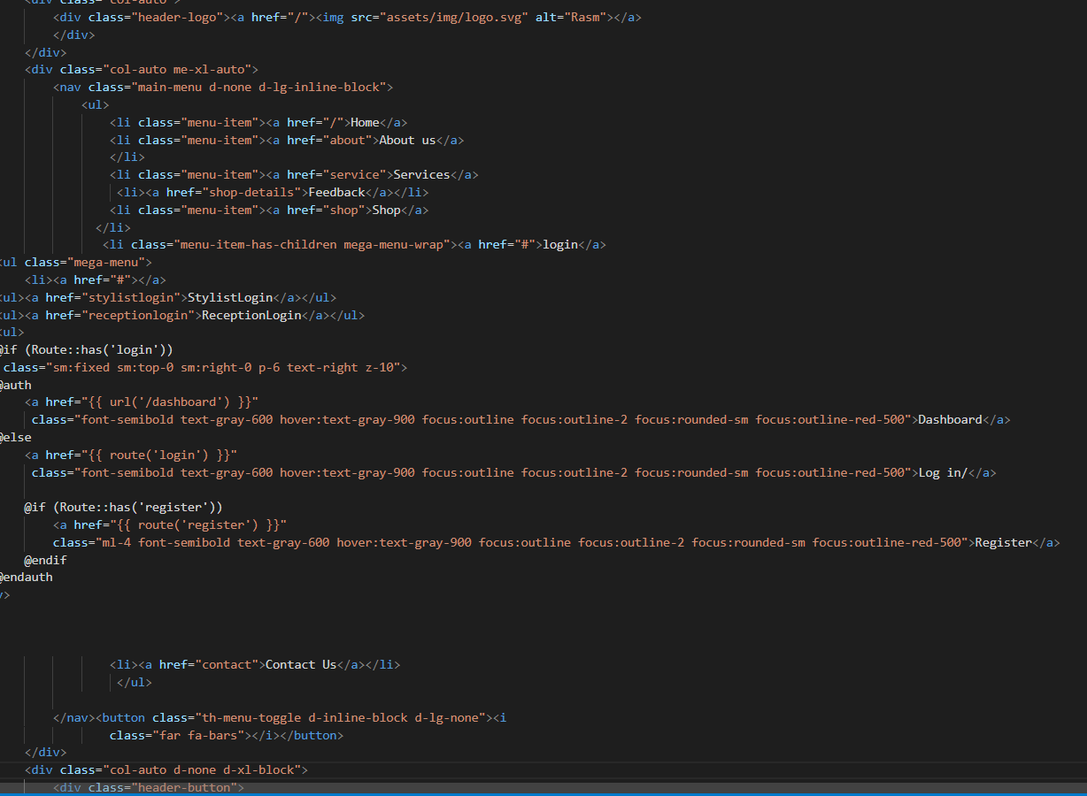

Footer:

This footer is also a part of (head_foot.blade.php)file .

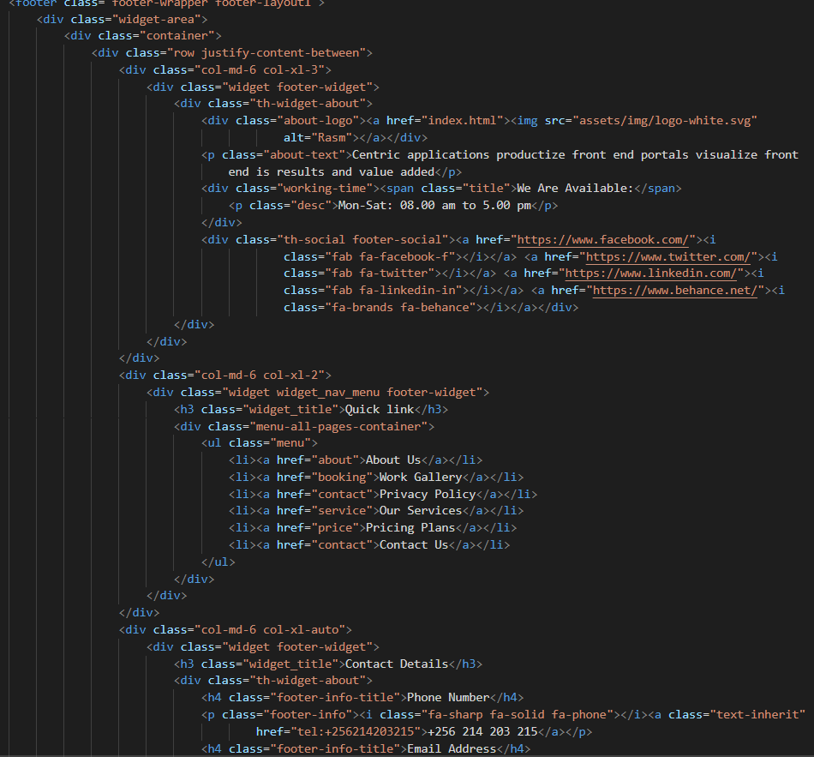

Home Page:

In this page user can see dynamic receptioinsts , stylists and also get acknowledge by new blogs which are coming from admin dashboard .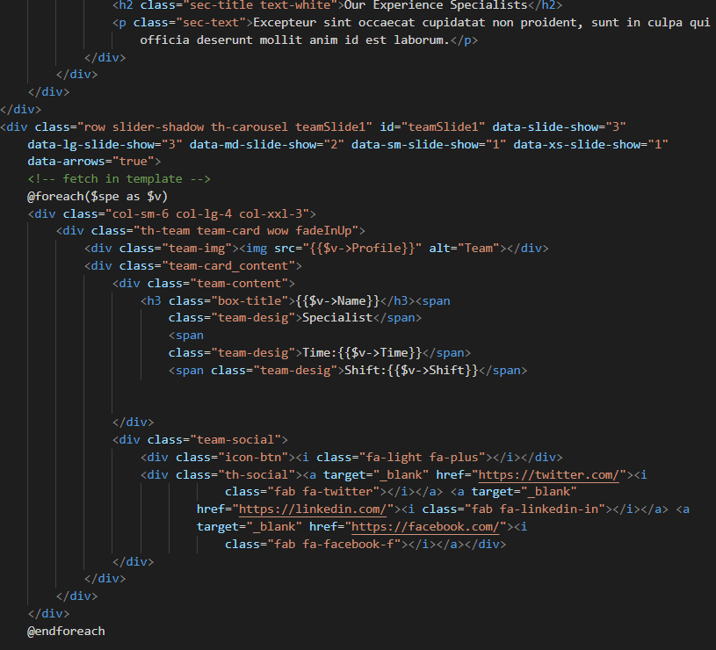

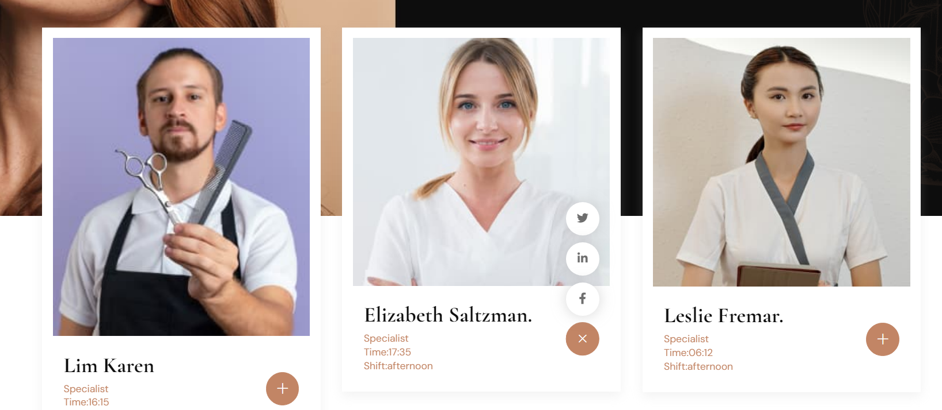

Receptionists section in index.blade.php(home file).

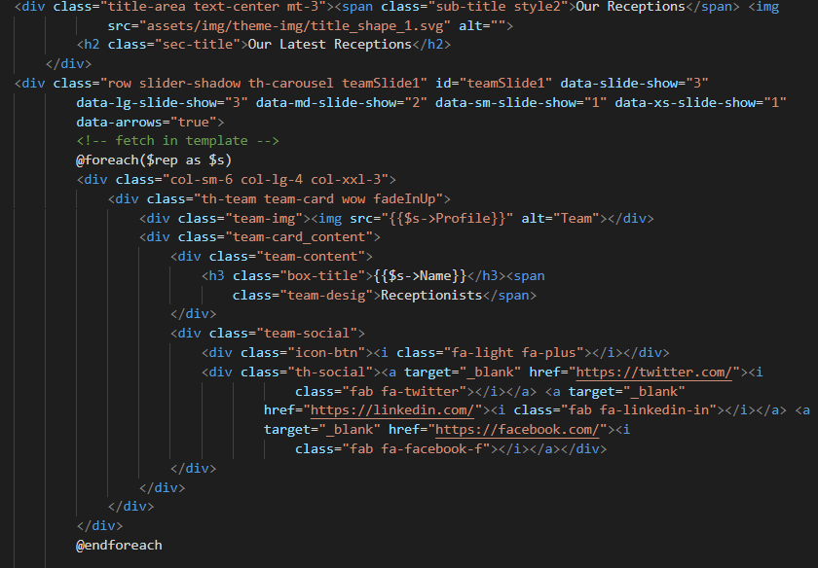

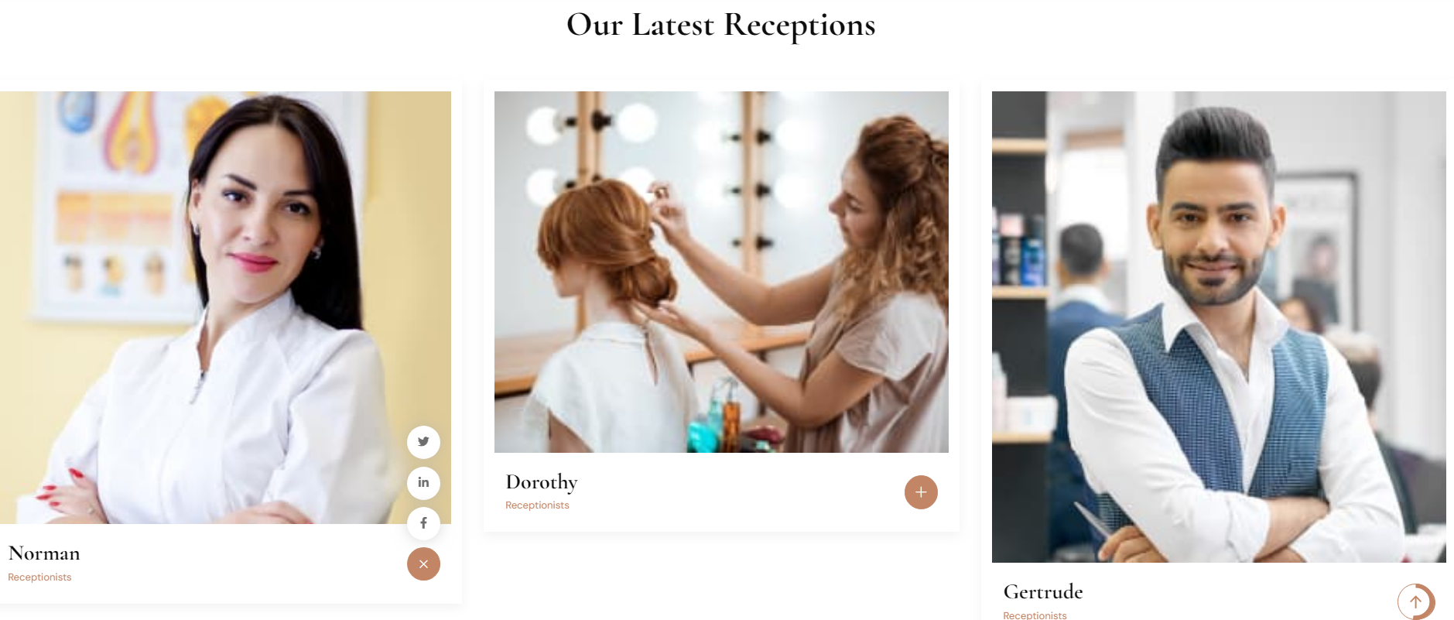

And this is blog’s section for users on home file 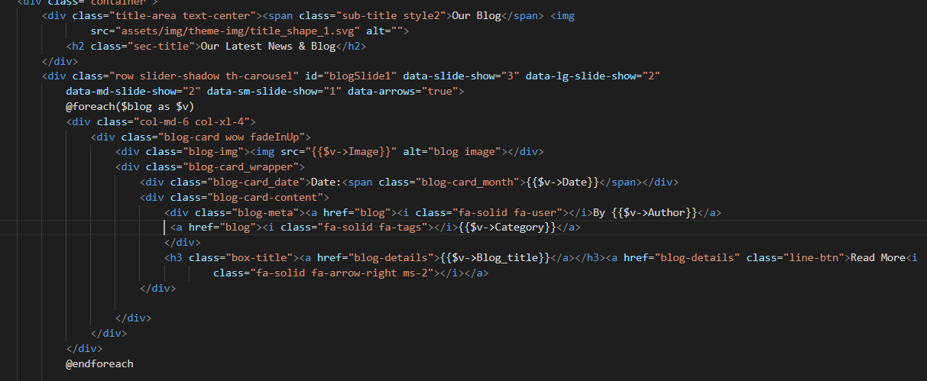

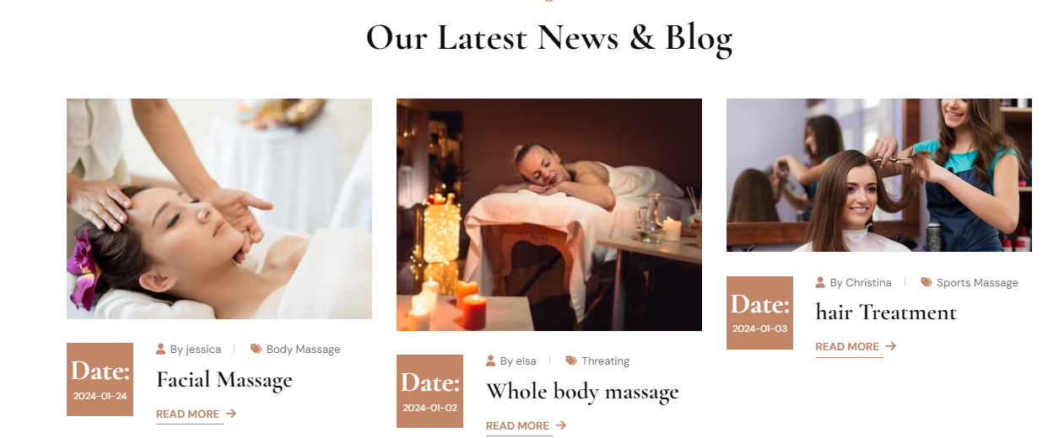

About Page:

In this page user can be acknowledge by our latest specialists and customers’s feedback on their work also with a beauteous and divine UI . 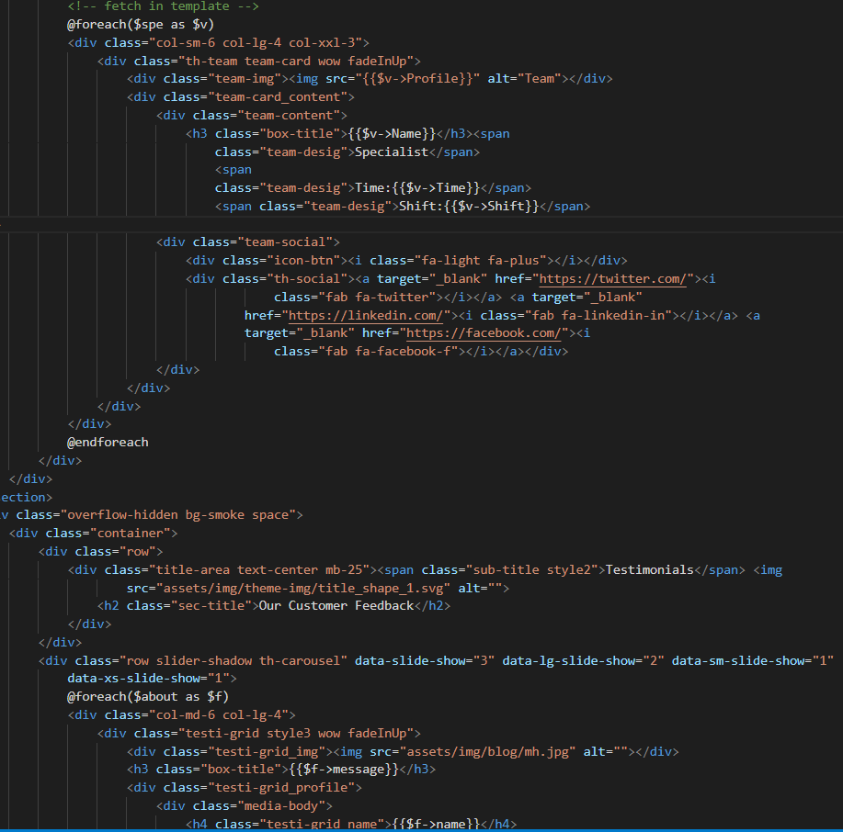

Services Page:  
Here user can see the services provided by the admin in this website also can book appointment by clicking on the button . 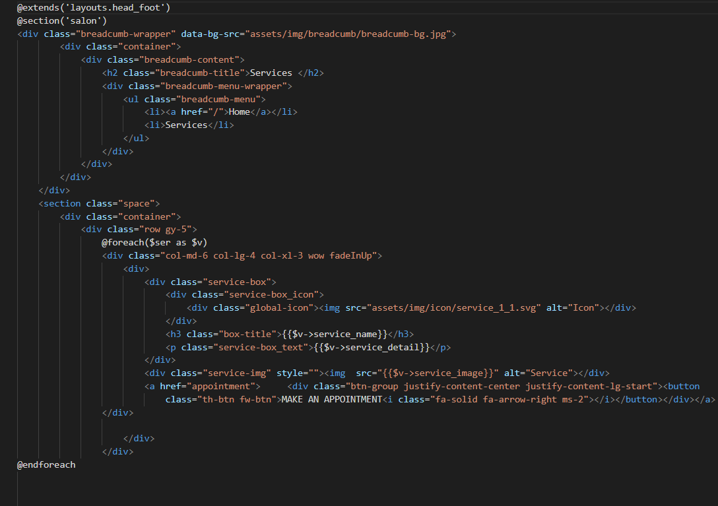 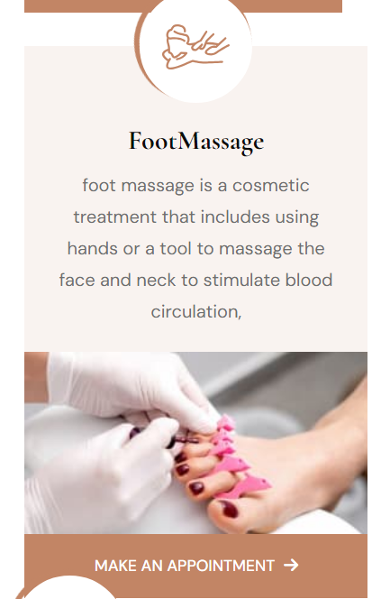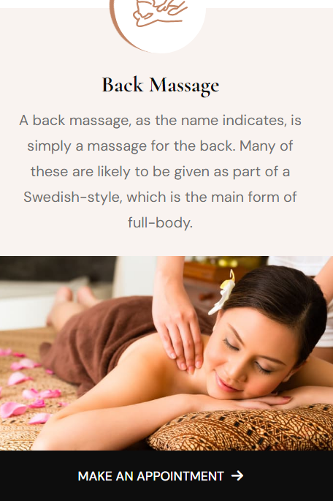

Feedback Page:

In this page user can add their feedback which can be show on the uppersite of the form of feedback and all the fields are validate user must have to fill all inputs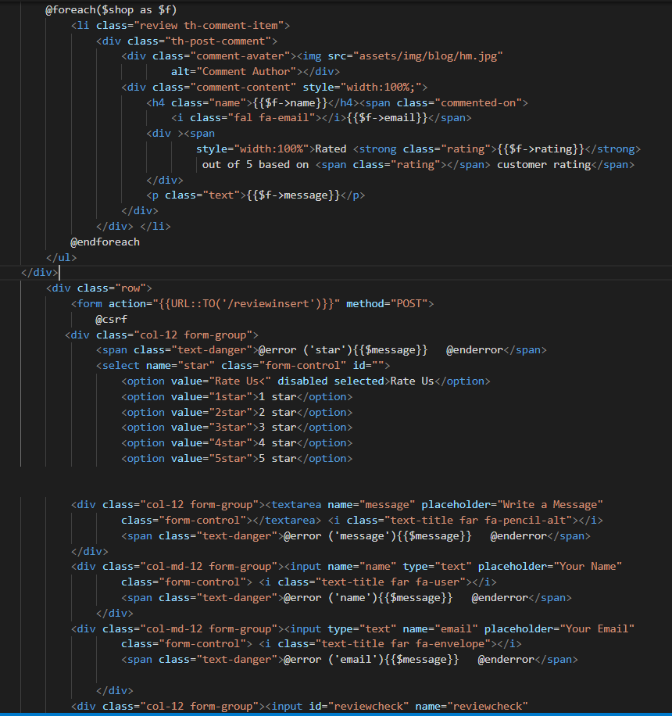 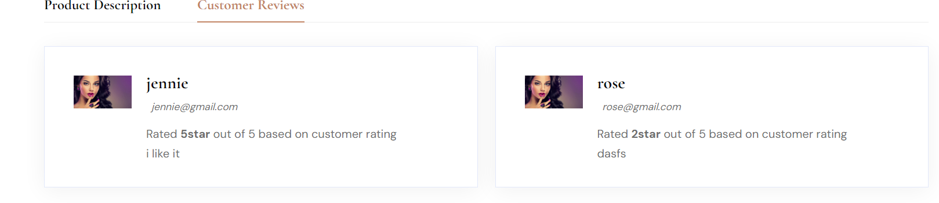

Shop Page:

In this page user can easily shop or buy any product they want which are also coming from admin dashboard and can add into a cart according to their wish. 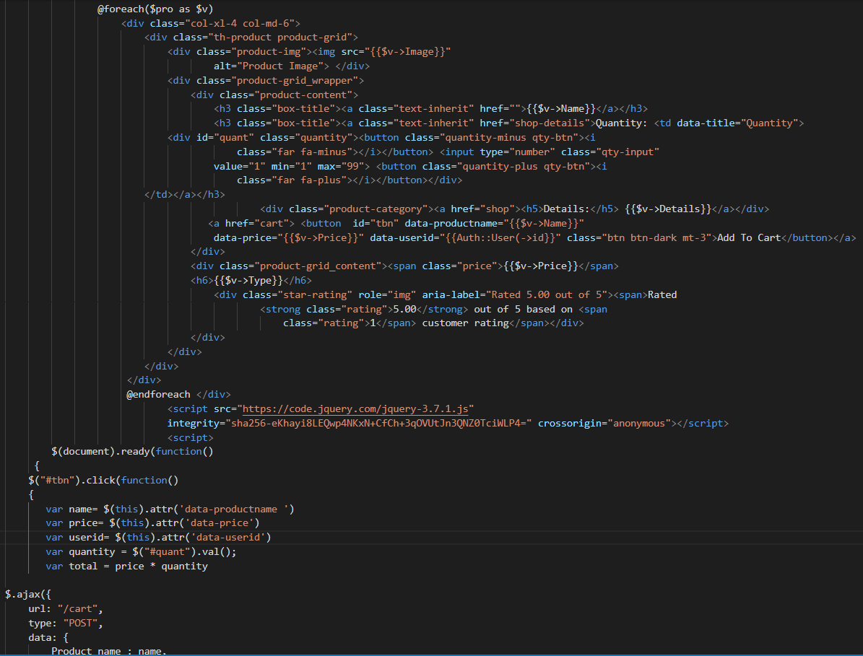

Contact File:

Through this file user can easily communicate with us these fields are also validate so user must’ve to fill all the inputs . 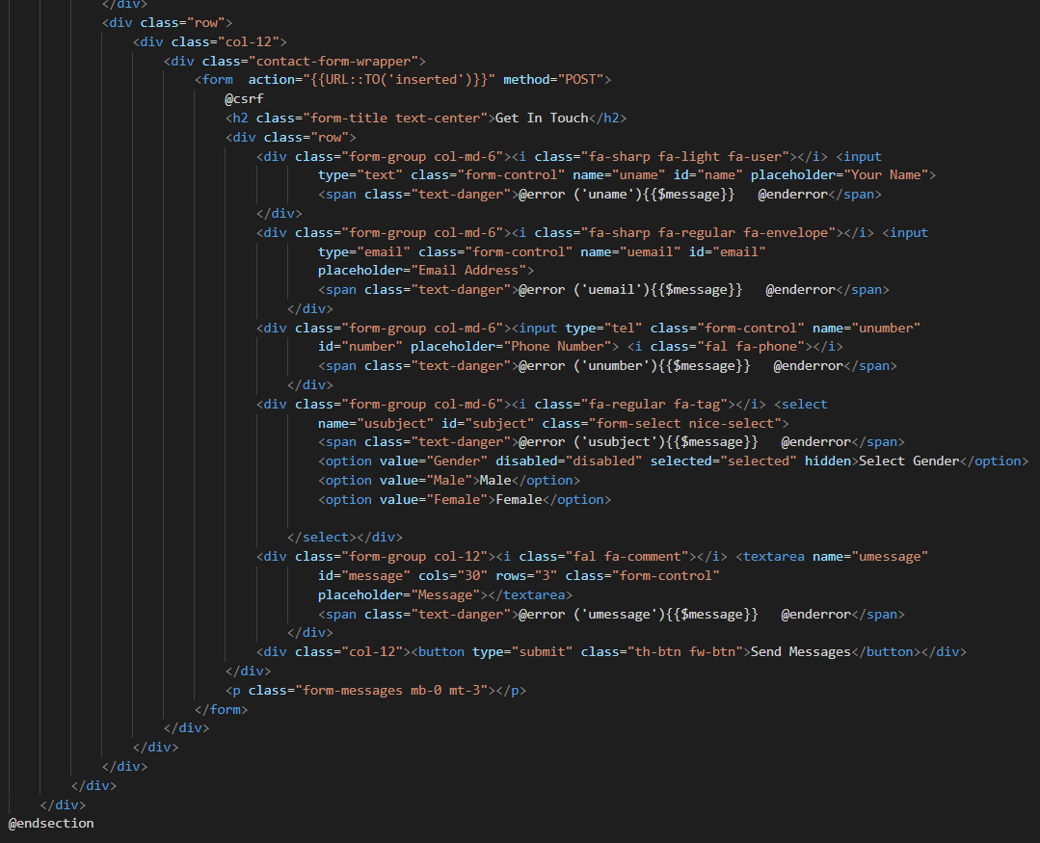

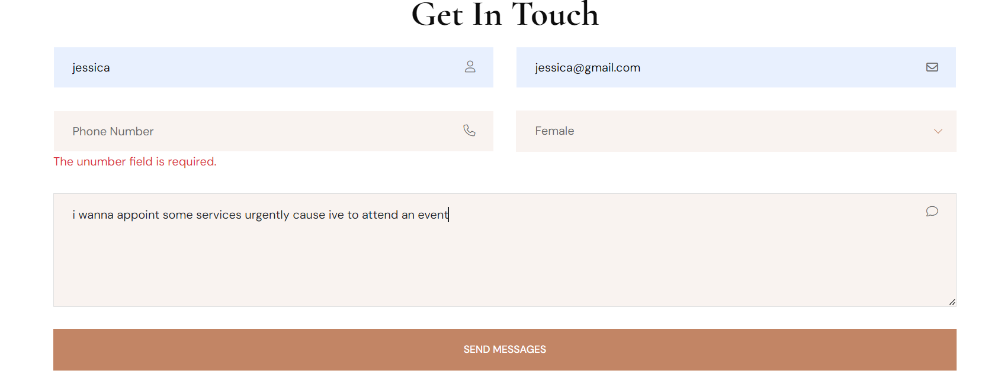

Appointment File:

In this file user can easily book an appointment with their selective staff(stylist) and also can pay the bill by clicking on the checkout button .

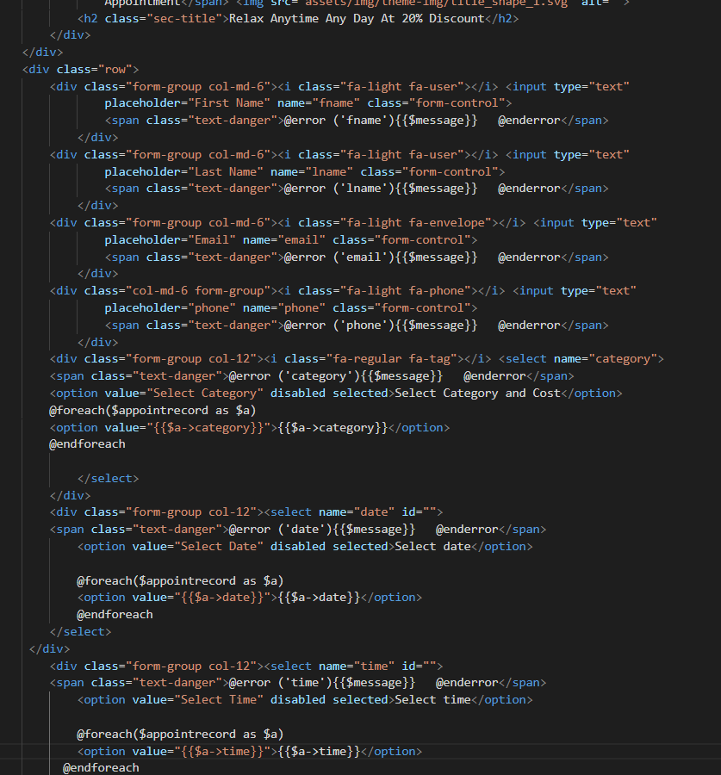

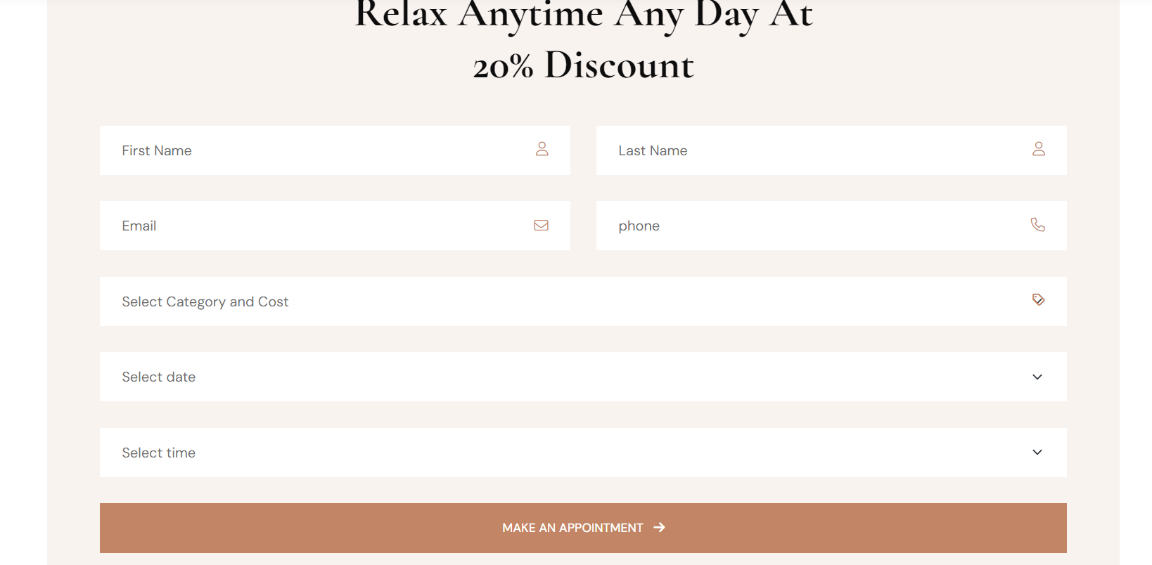

Checkout form: 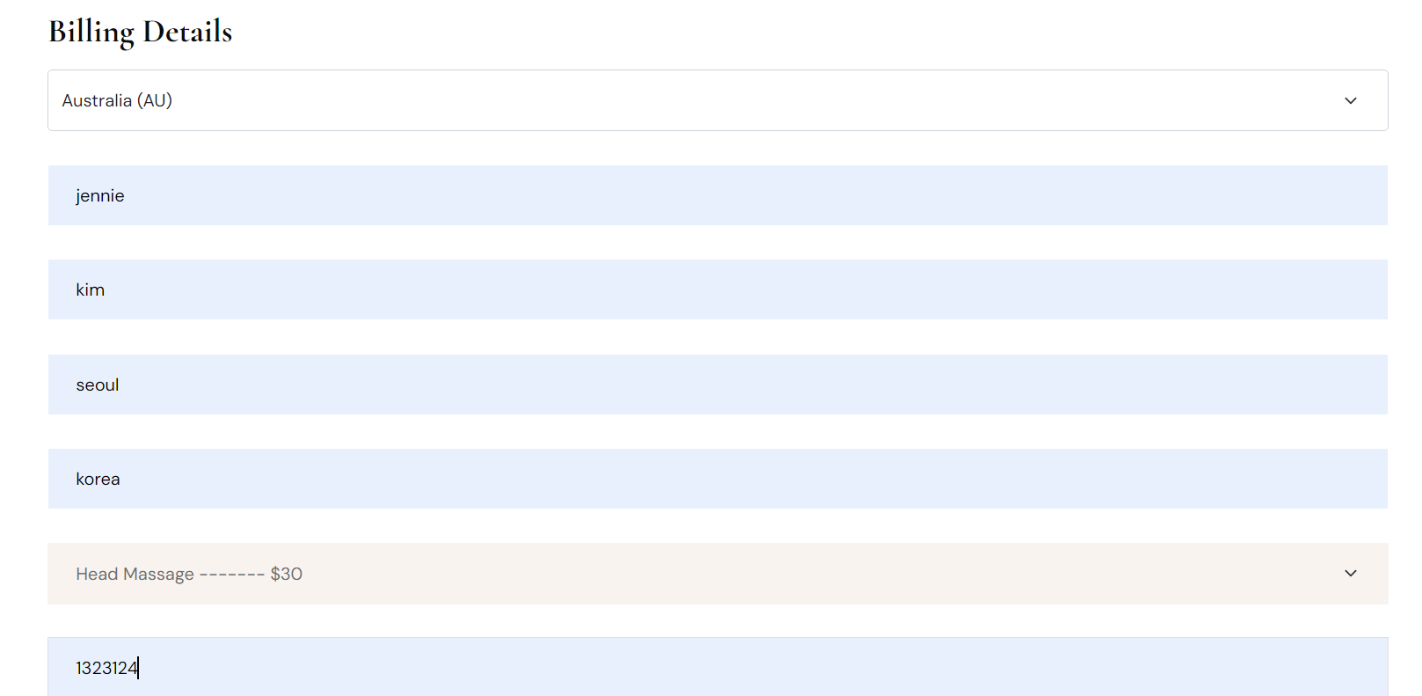

In this file or through this form user can easily pay a bill of their selected services and appointments and can also select the method of payment. 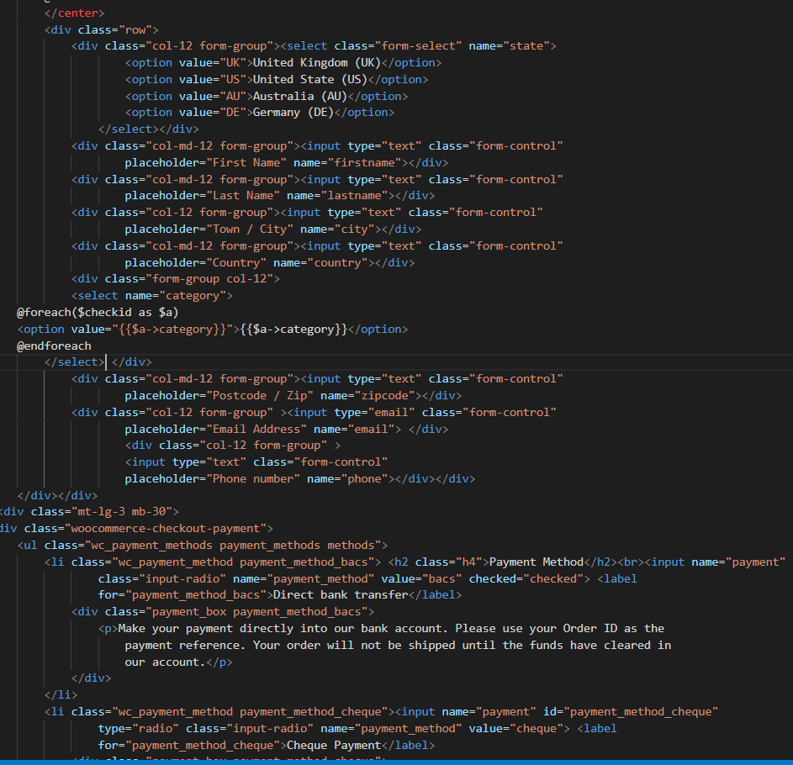

Cart Page:

Through this file user can easily analyze the products which they added from the shop file also can delete their unwanted products and can also have a glimpse of the product’s price as well.

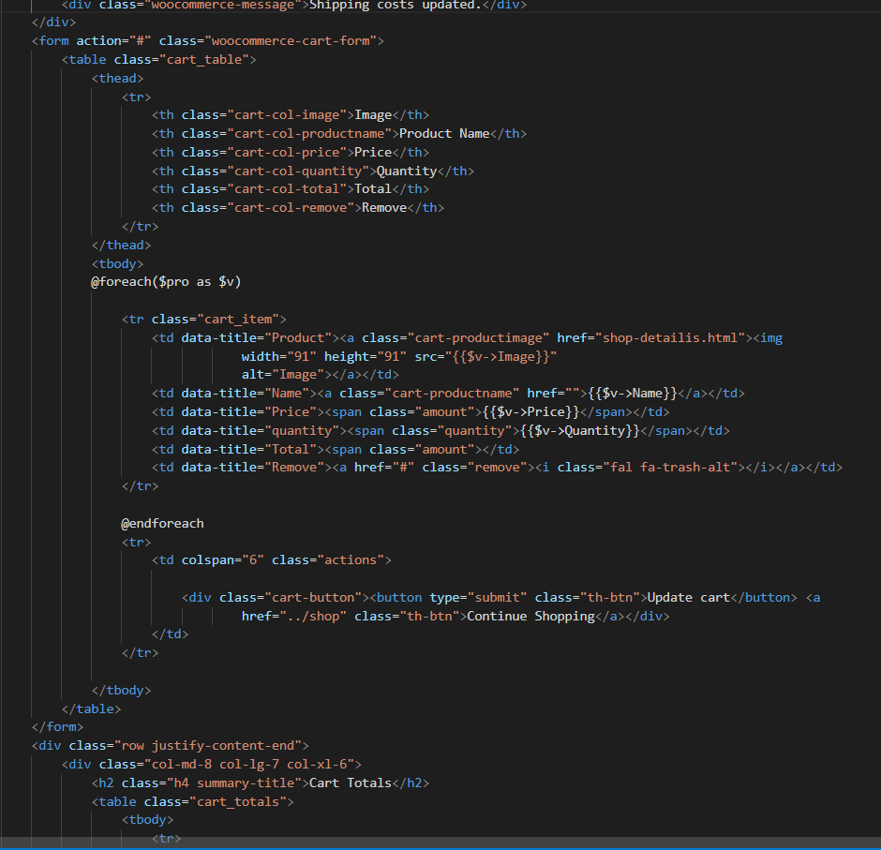

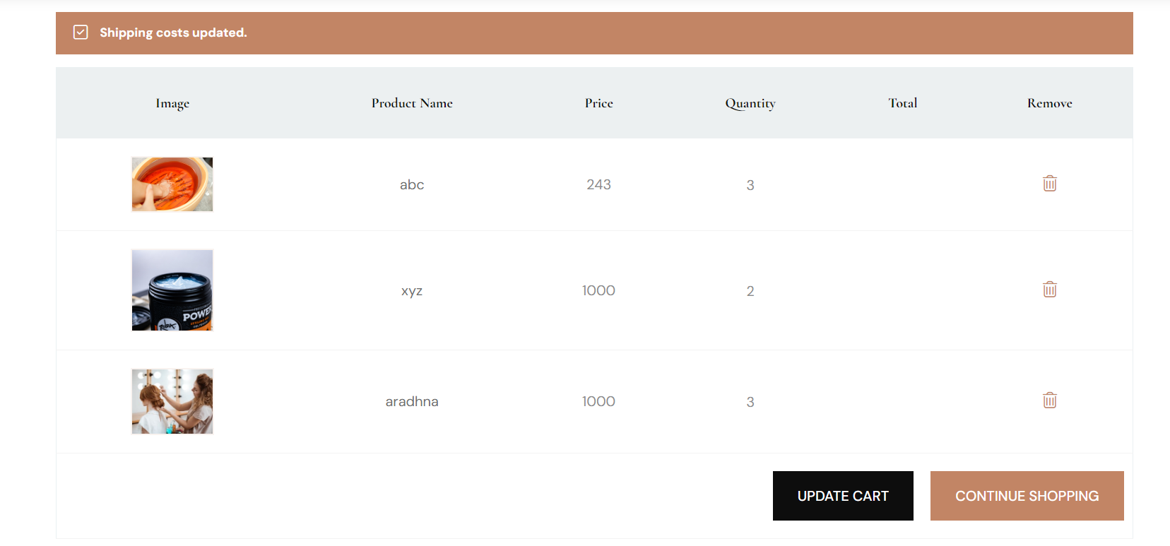

*There are 4 of dashboards:*

* **Admin Dashboard**: in this admin can insert and fetch products on websites and dashboard also can insert salary of stylist and receptionist and can update some of the records.
* **Receptionis**t Dashboard. In this receptionist can distinguish the appoints book by users also can behold their salaries and can add , fetch product as well.
* **Stylist** Dashboard. In this stylists can distinguish the appoints book by users also can behold their salaries.
* **User Dashboard**: in this user can analyze their appointments and can check their details.

Admin Dashboard: 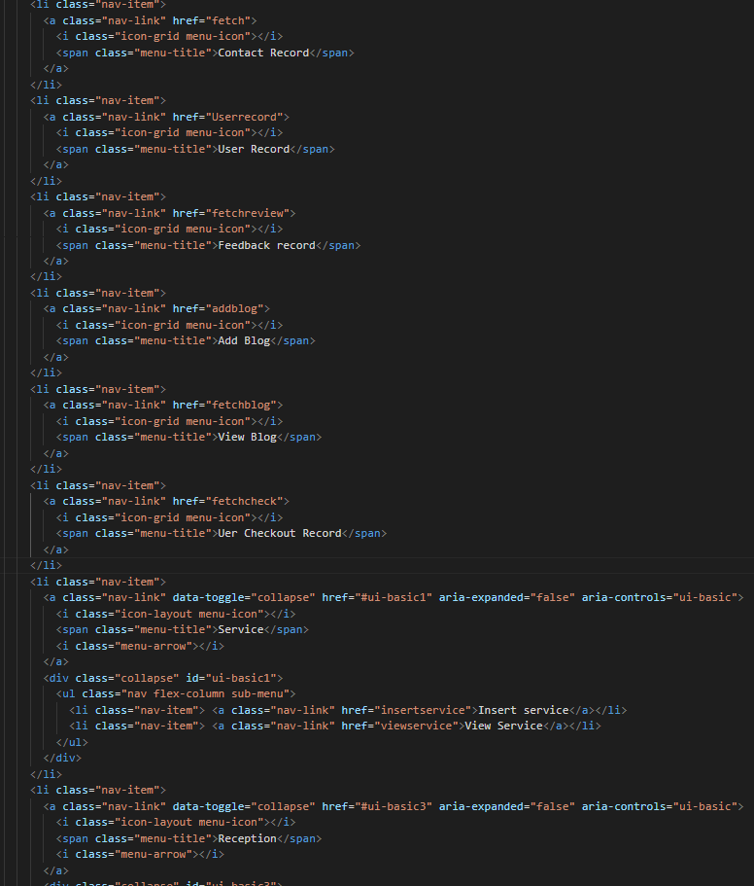

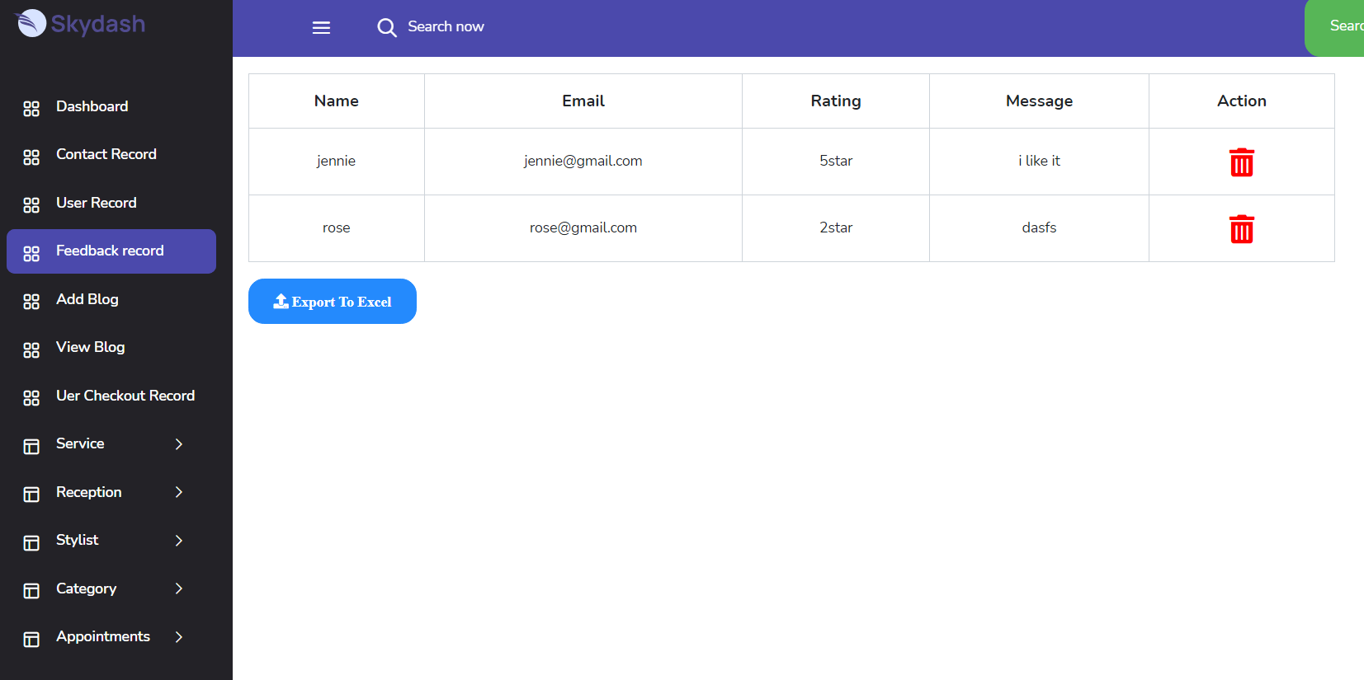

User Record fetch,Delete,export & Update : 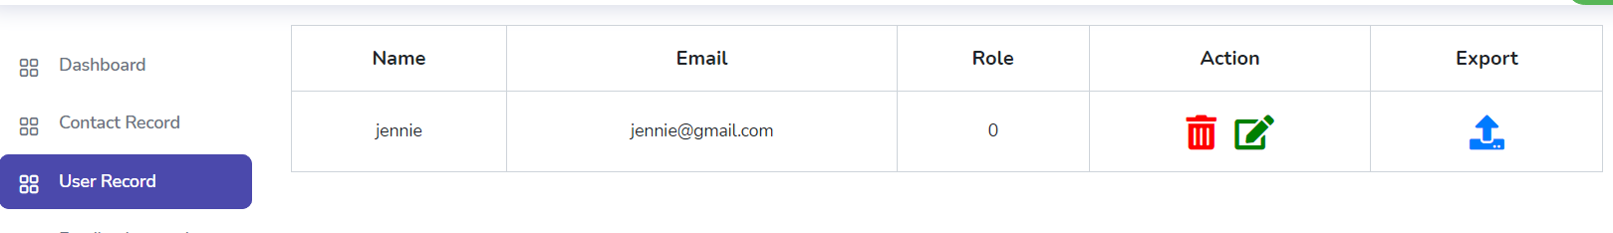

Feedback Record fetch,Delete & Export : 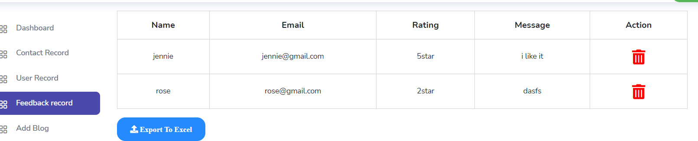

Add Blog ,View & fetch: 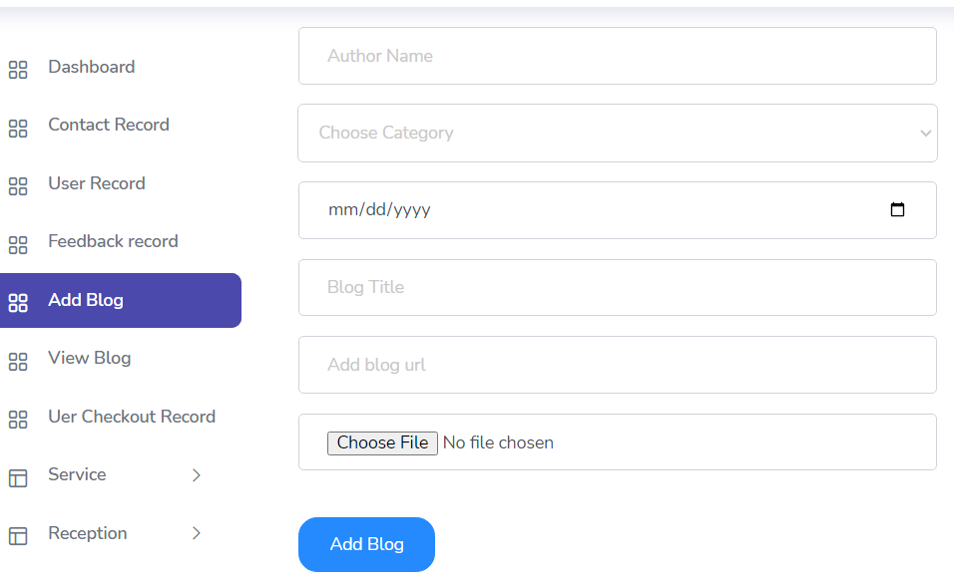

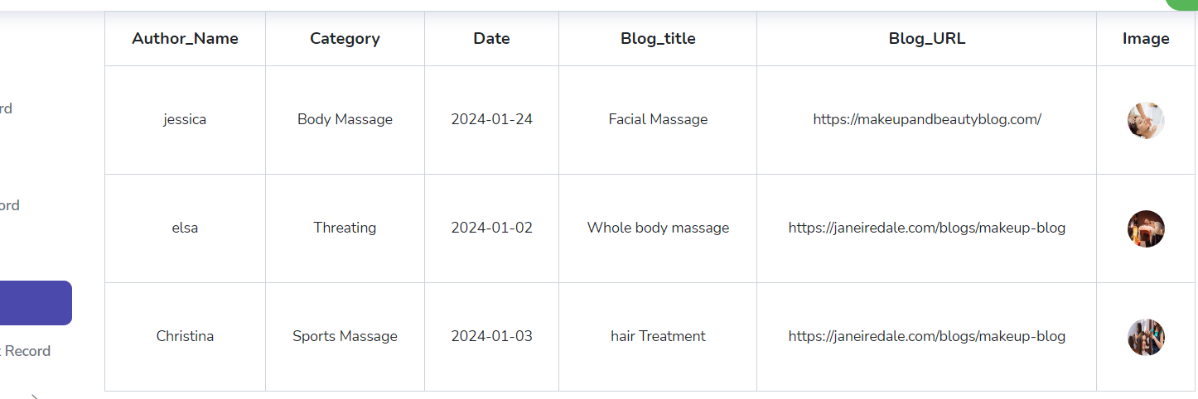

User Checkout Record Delete, Export & fetch: 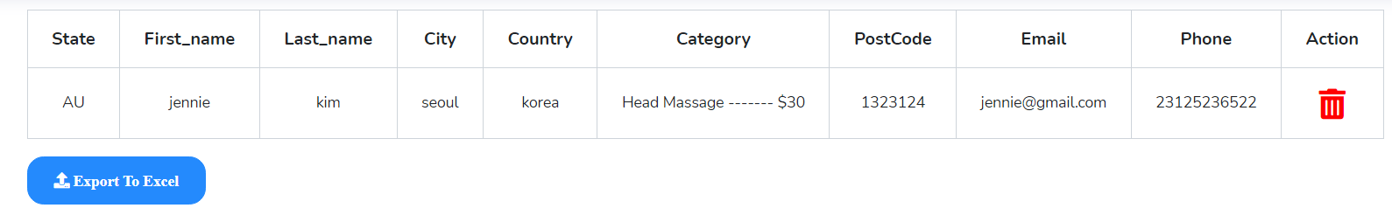Service Record Insert , Fetch , Delete & Export: 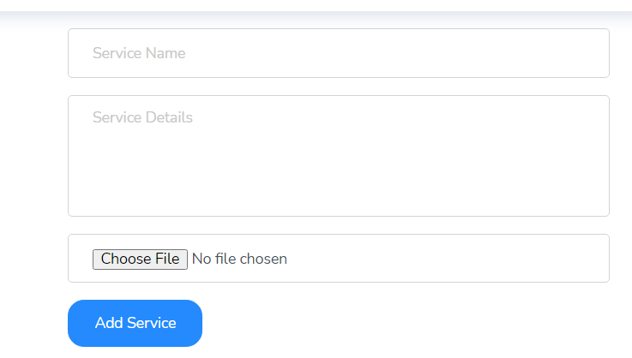

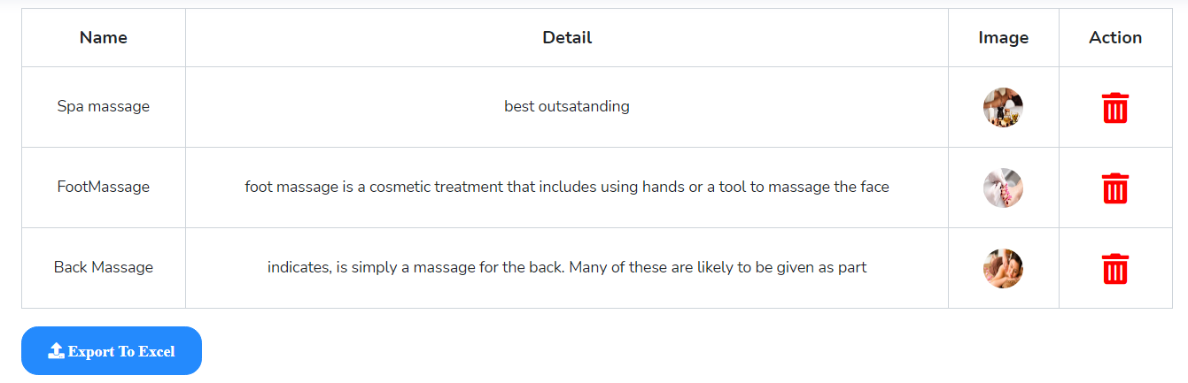

Receptionists Record Insert, Fetch,Delete,Update & Export: 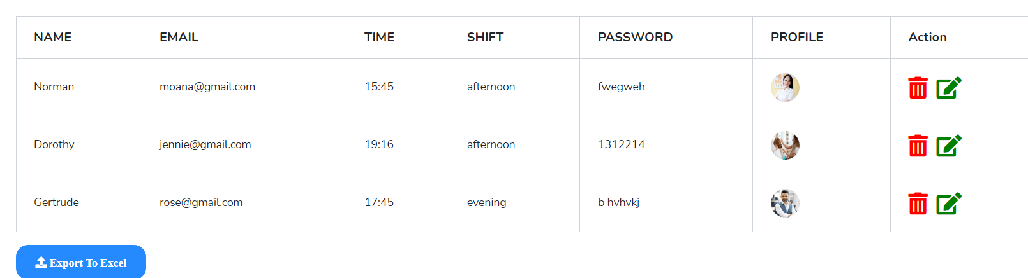

Stylists Record Insert, Fetch,Delete,Update & Export: 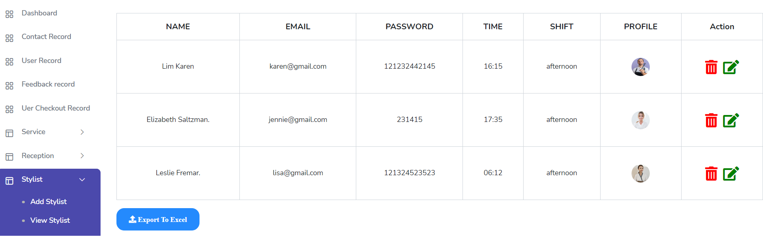

Category,Date,Time Record Insert, Fetch,Delete & Export: 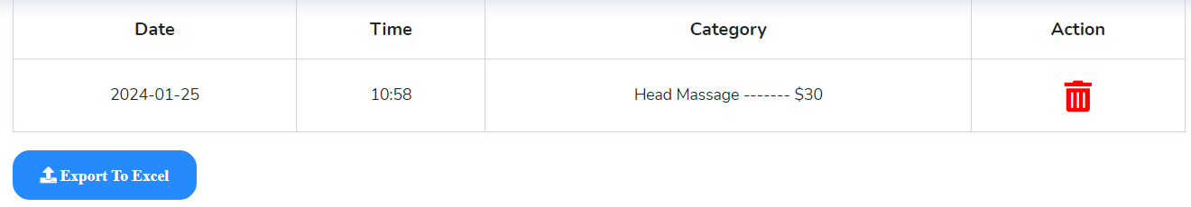

Appointment Record Fetch,Delete,Update & Export: 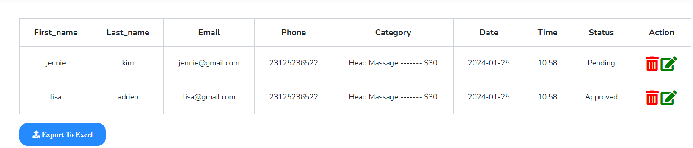

Contact Record Fetch,Export & Delete :

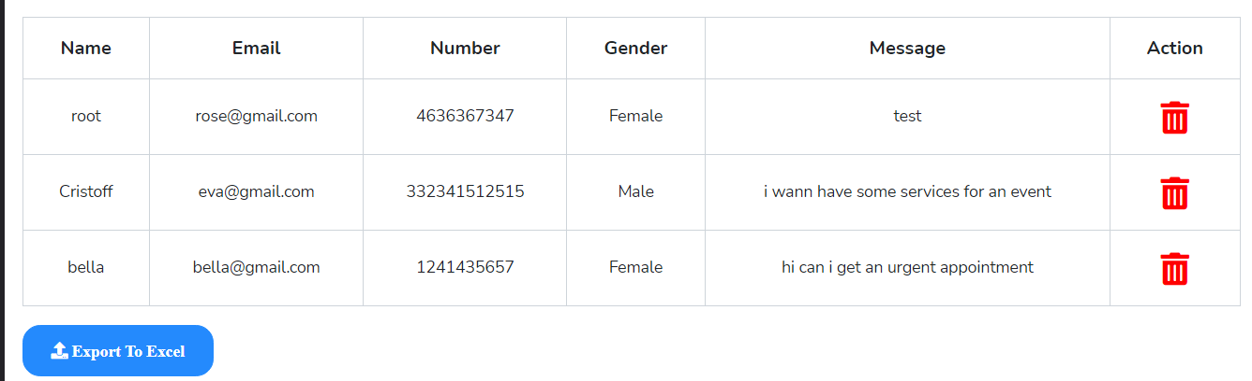

Controller 🡪 Admincontroller:

In this file admin made a functions which were the reason of ambitious and burdensome errors

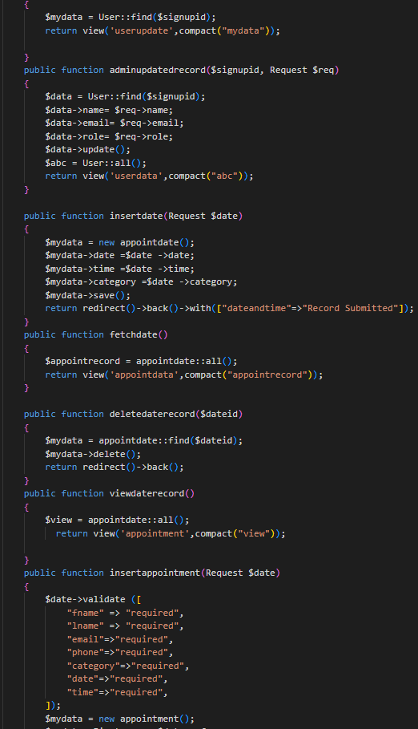

Routing(Web.php):

In this admin made a routes to let our functions of admincontroller run. 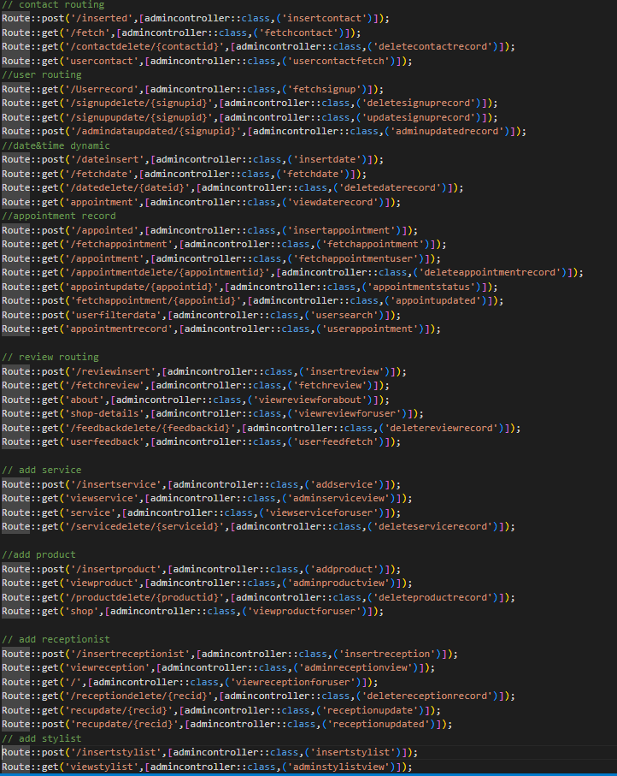

File’s Names:

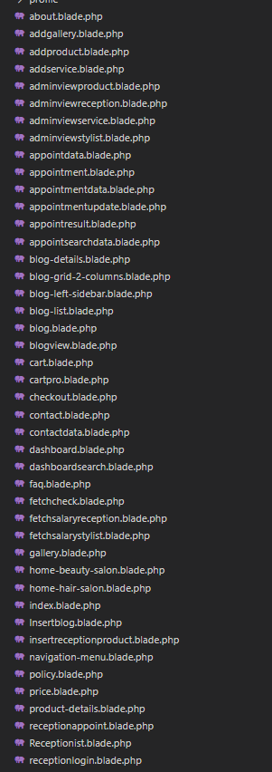 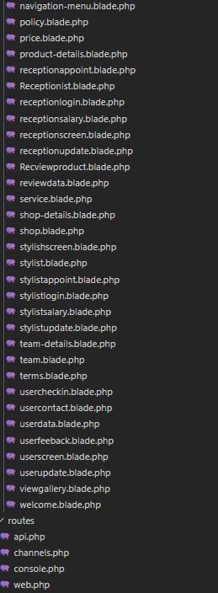

Database Design: 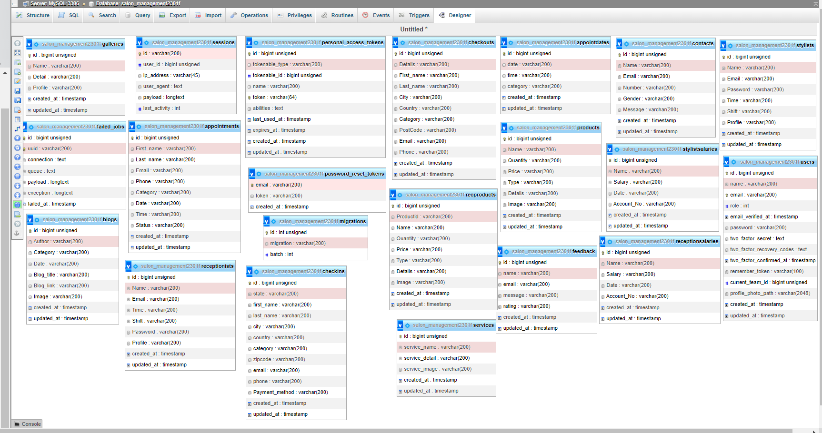

**Thankyou So Much For Reading Our Documentation**